Predicting Groundwater

By dividing some period of time into equal spans, and summing rainfall within those spans, it is possible to create a set of inputs to a statistical model (such as a linear regression model) that can 1) predict groundwater elevations with a high degree of accuracy, and 2) convey the relative importance of rainfall at each timespan.

For example, a system of near-surface groundwater with relatively porous soils might respond to rainfall within a few days or weeks. Given a well with continuous (ideally daily) logging of water elevations over multiple years, each water elevation observation can be paired with series of variables describing the sum of rainfall over the past week, week prior to that, etc.

Example Table

|  |  |  |  |  |  |
| --- | --- | --- | --- | --- | --- |
| **Date** | **Elevation** | **Rainfall, Previous Week** | **Rainfall,**  **Two Weeks Ago** | **Rainfall,**  **Three Weeks Ago** | **Rainfall, Four Weeks Ago** |
| 2017-01-01 | 20.15 | 0.41 | 0.23 | 0.50 | 0.01 |
| 2017-01-02 | 20.18 | 0.29 | 0.39 | 0.47 | 0.05 |
| 2017-01-03 | 20.21 | 0.31 | 0.11 | 0.43 | 0.05 |

The rainfall data are non-overlapping; that is, every drop of rain is counted once and only once within each row. However, because the rainfall sums are calculated dynamically for each row, one day’s worth of rain will be counted in many rows before it finally falls outside the counted range.

In the example table, rainfall for 2016-12-26 would be summed with “Rainfall, Previous Week” in row 1, because it is seven days prior to 2017-01-01. However, in row 2 the rainfall for the same day, 2016-12-26, would be summed with “Rainfall, Two Weeks Ago” because it is eight days prior to 2017-01-02.

# Thurston County Rain/Groundwater Models

## LRS-7

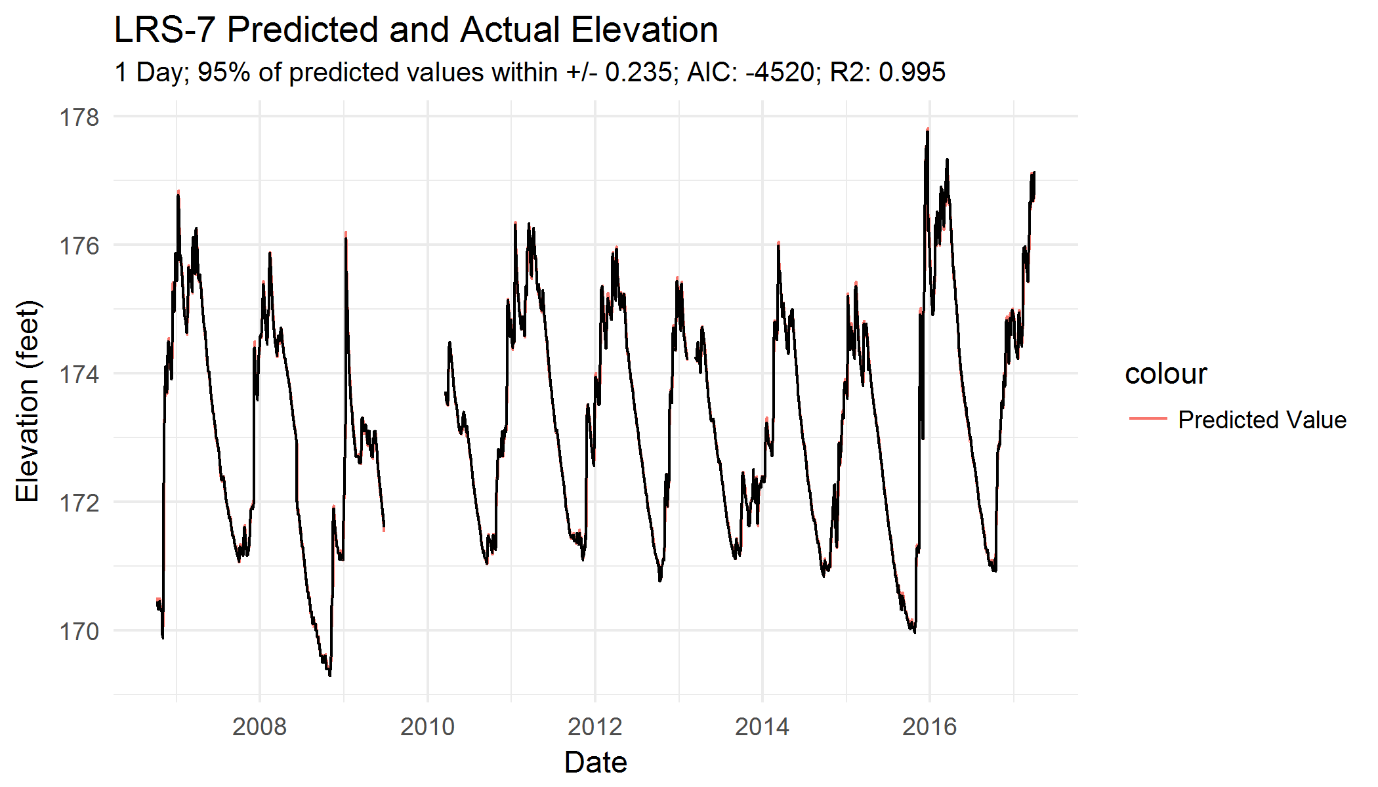

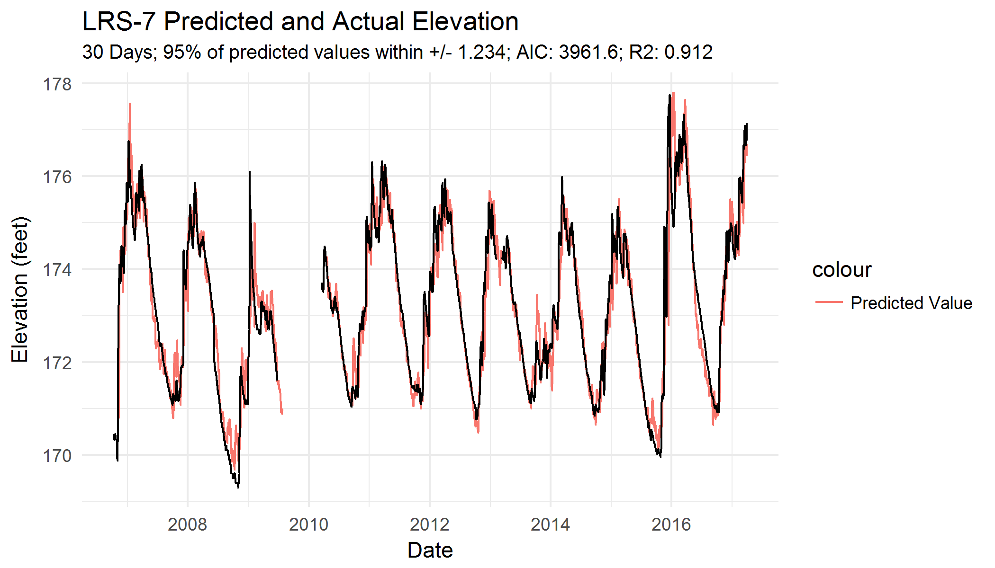

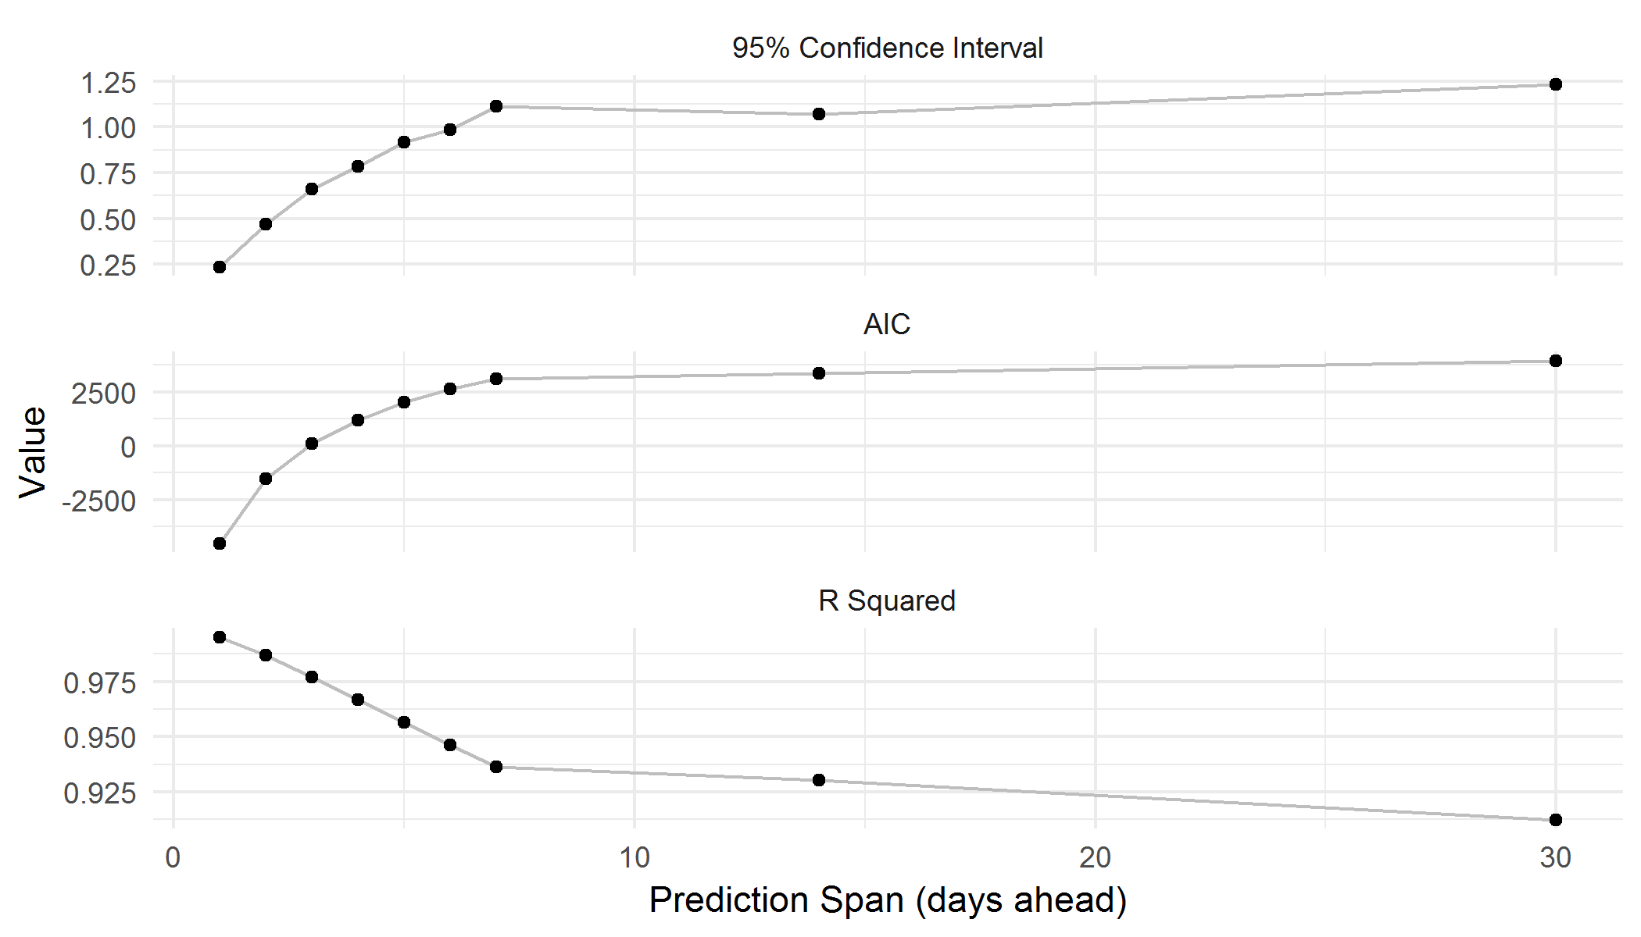

## LRS-8

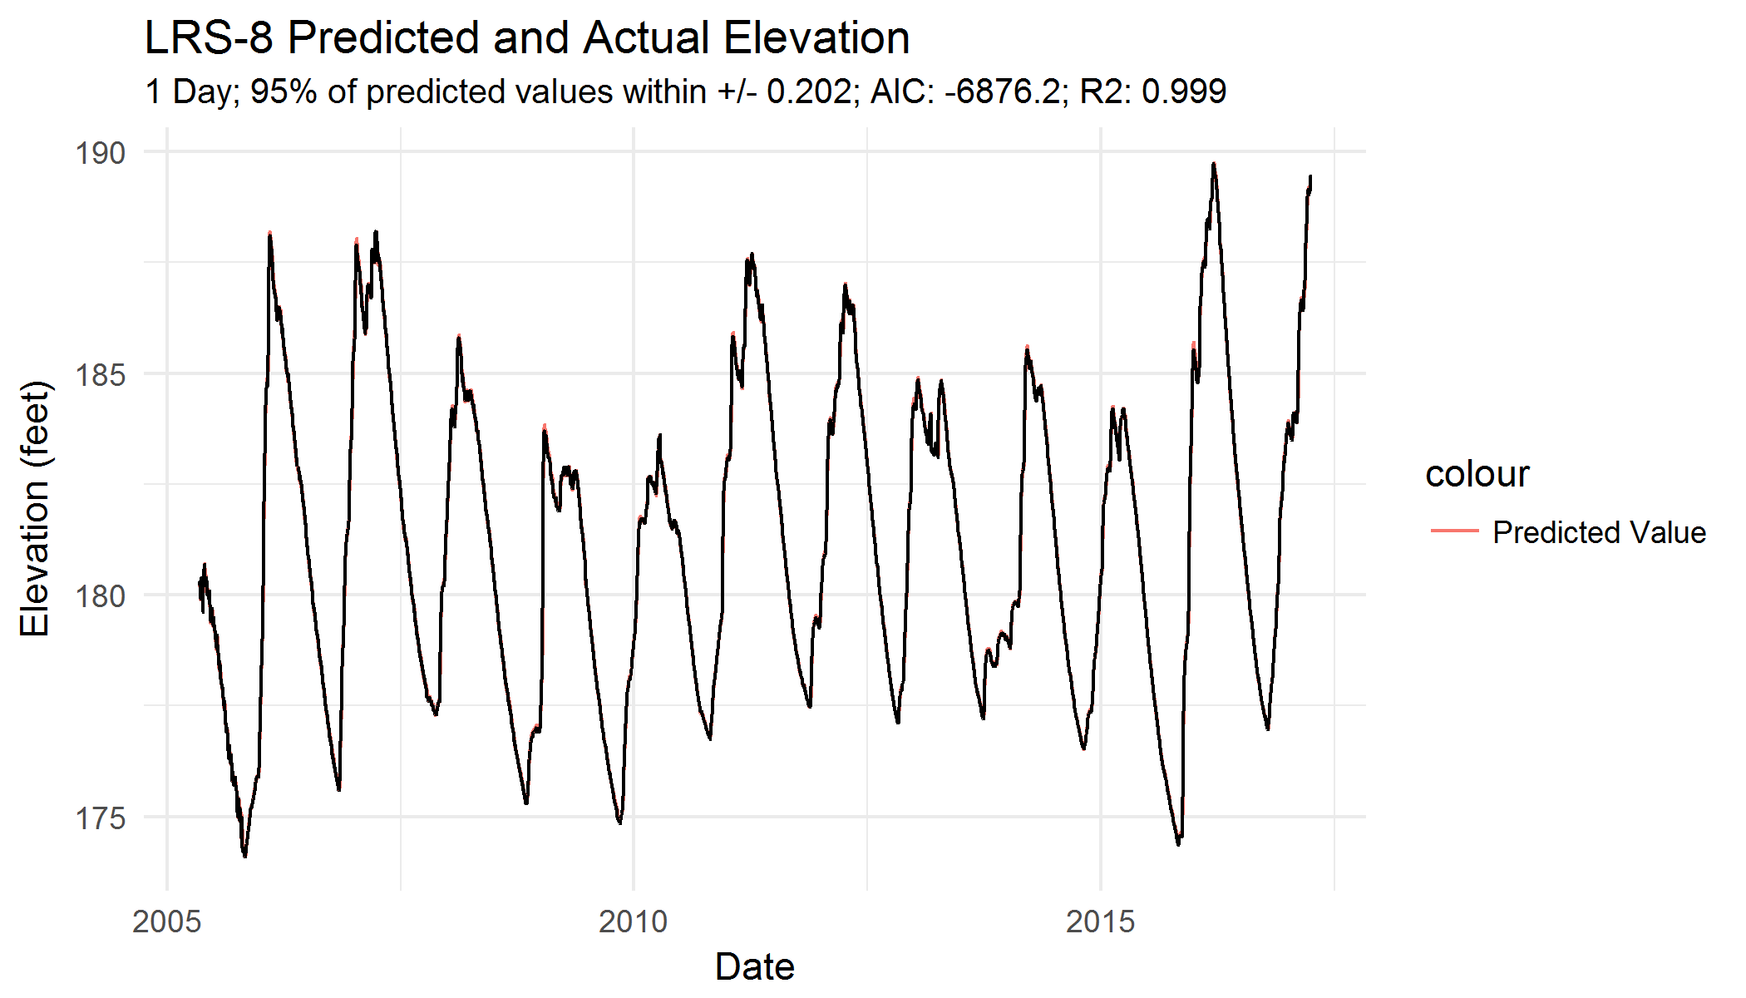

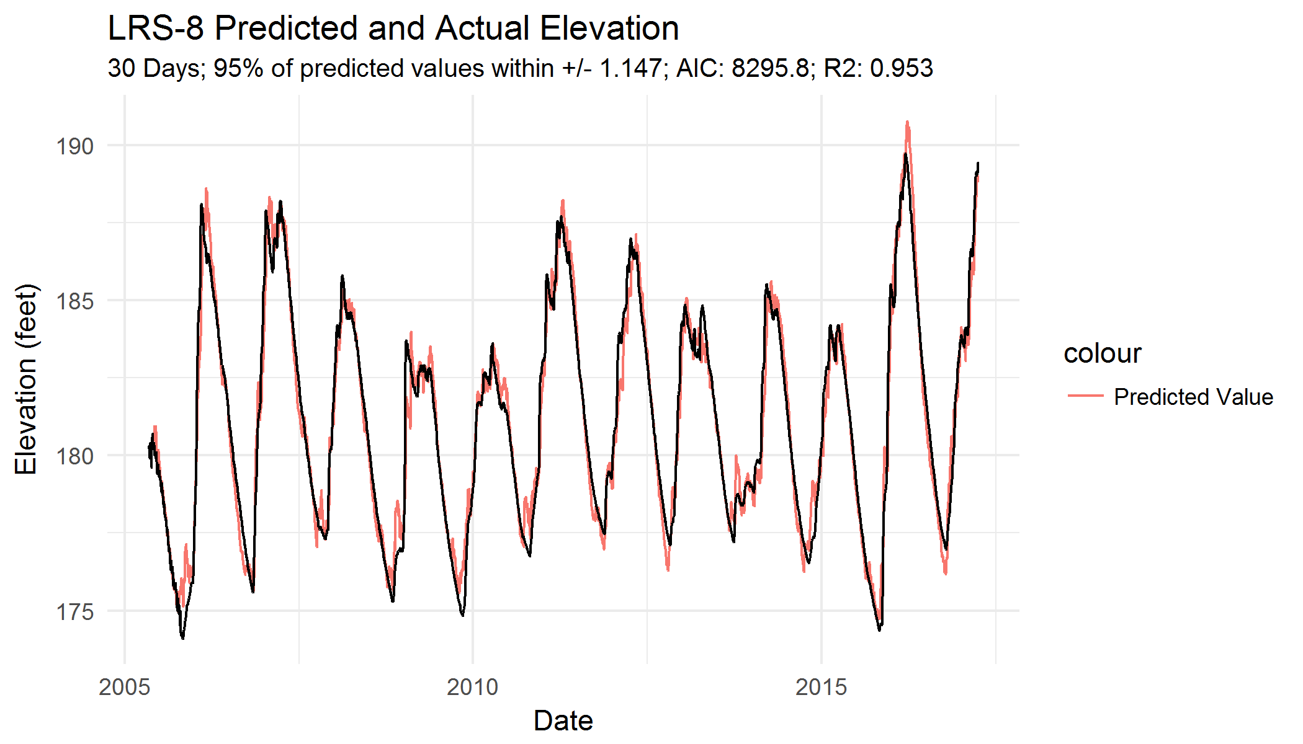

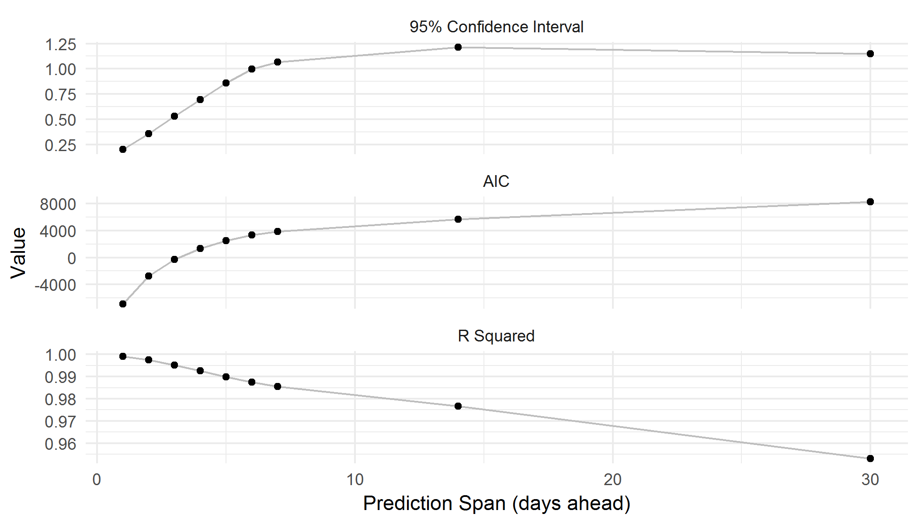

## LRS-9

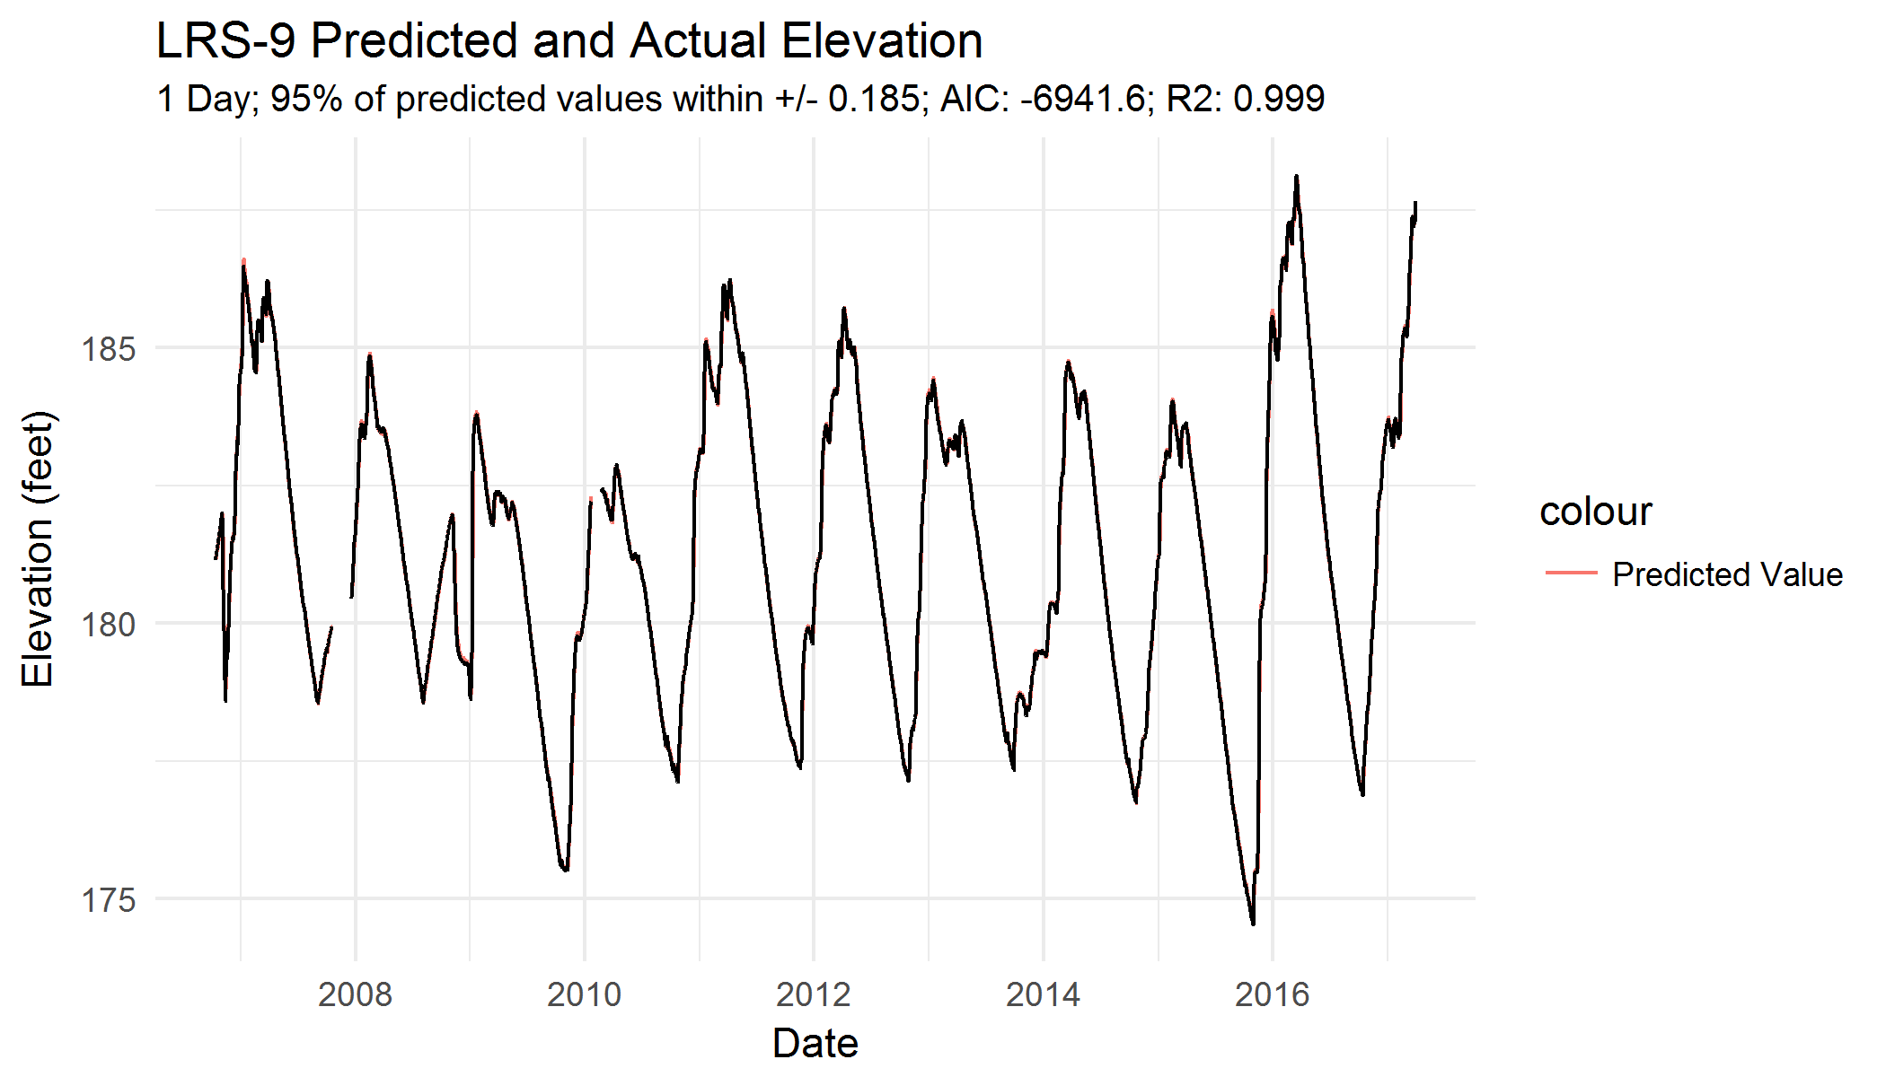

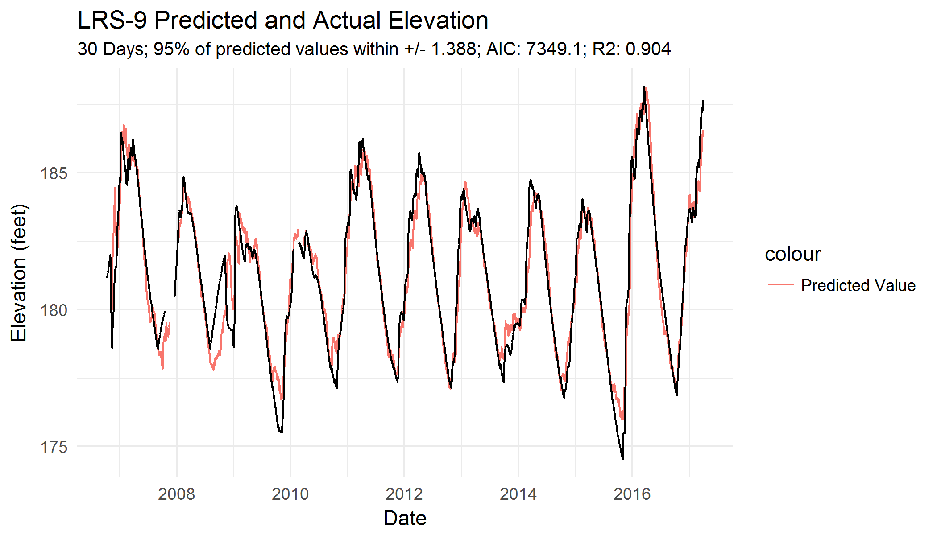

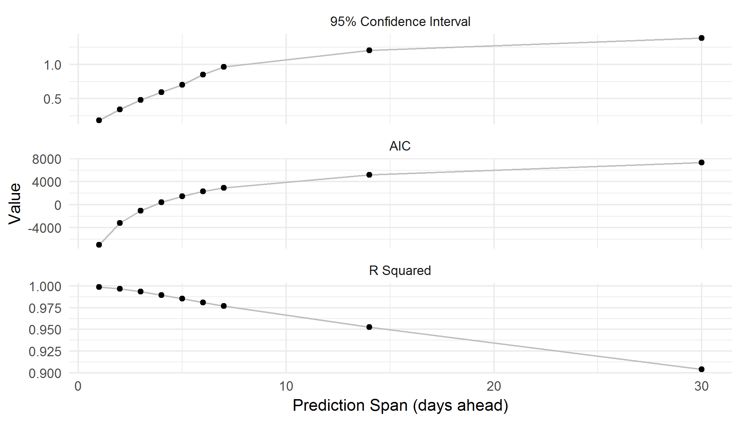

## LRS-11

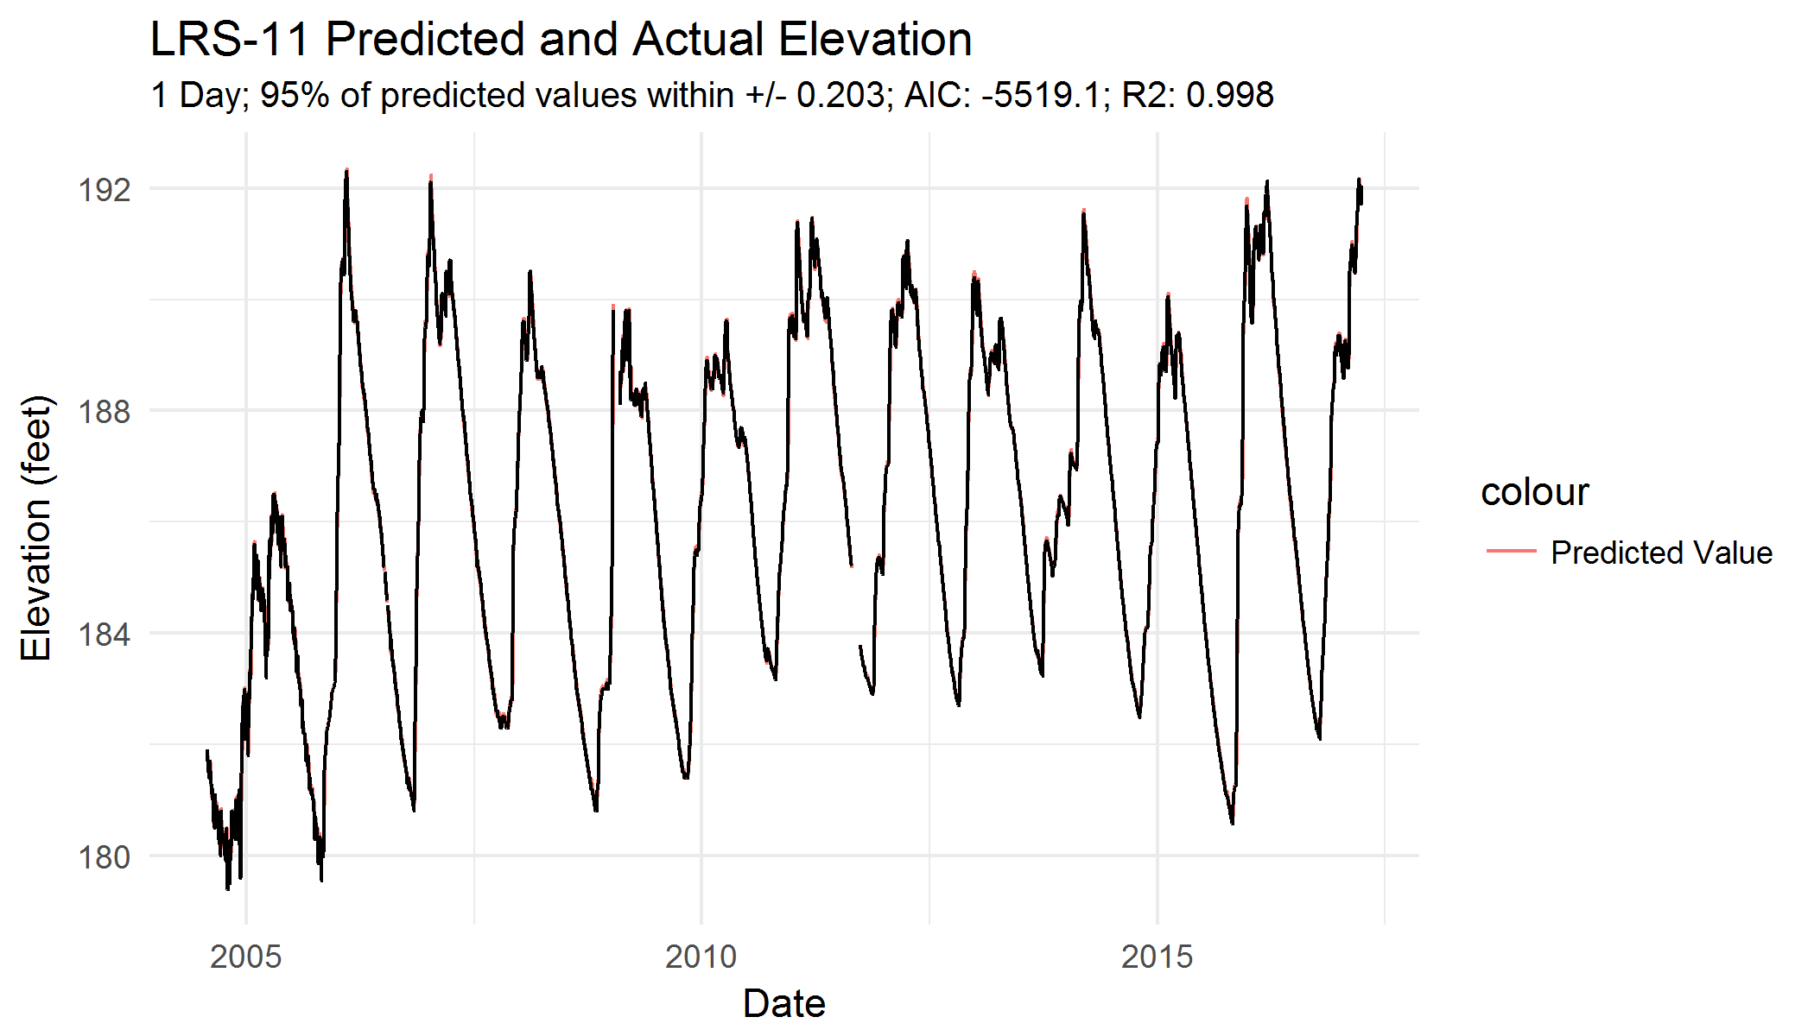

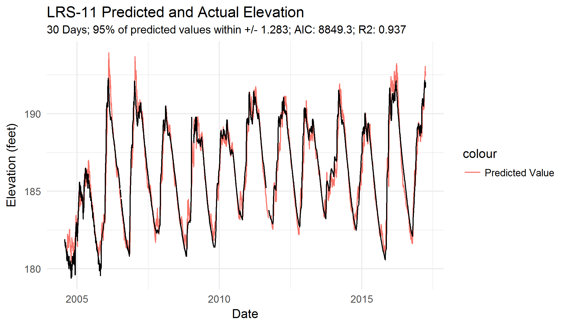

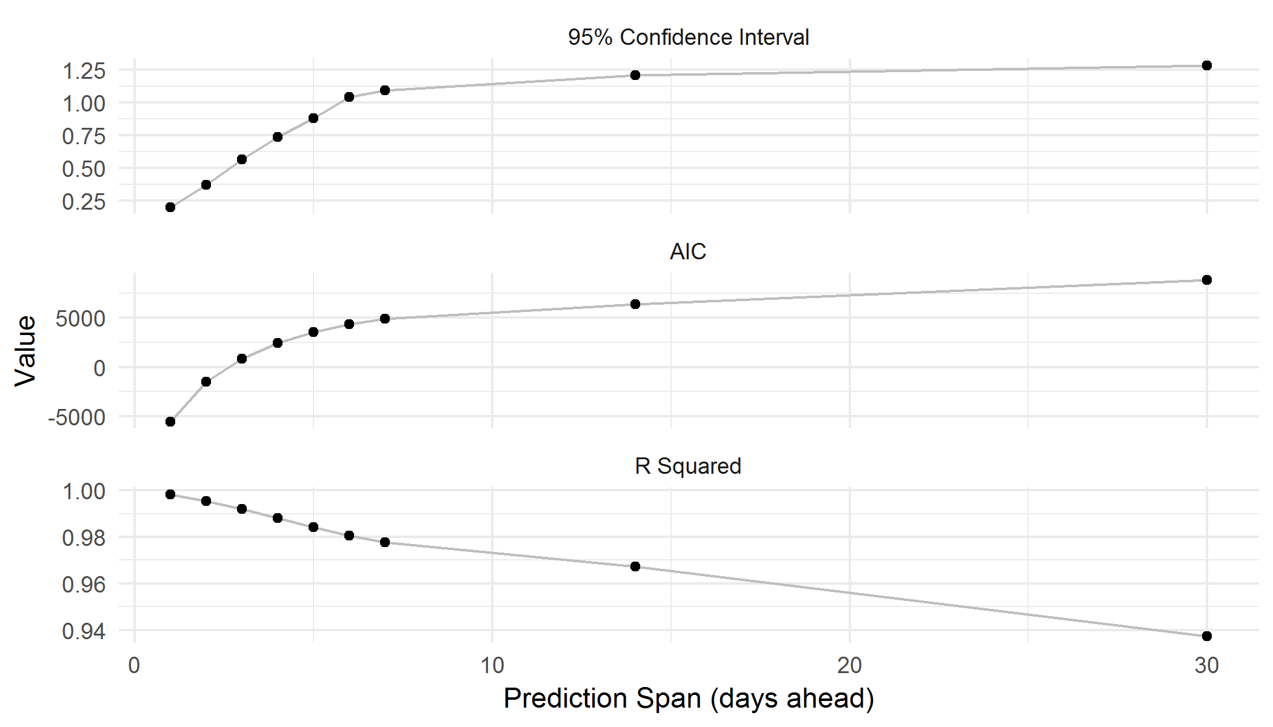

## LRS-12

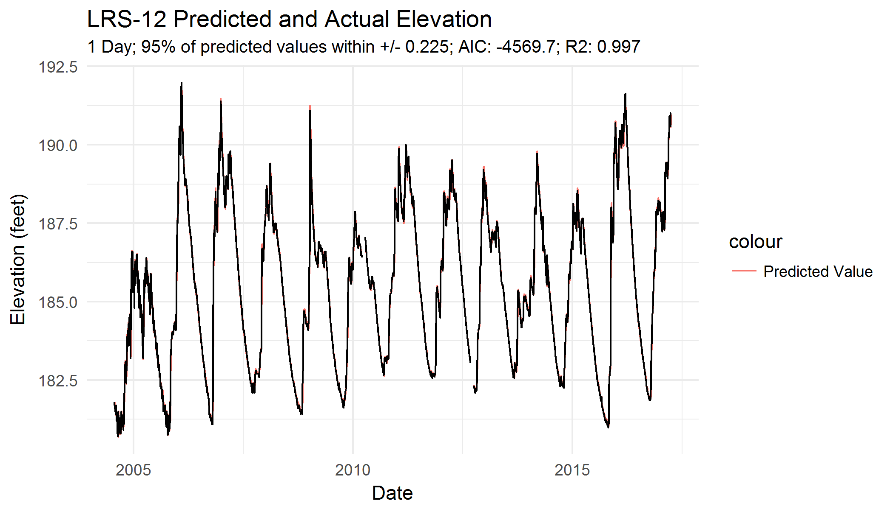

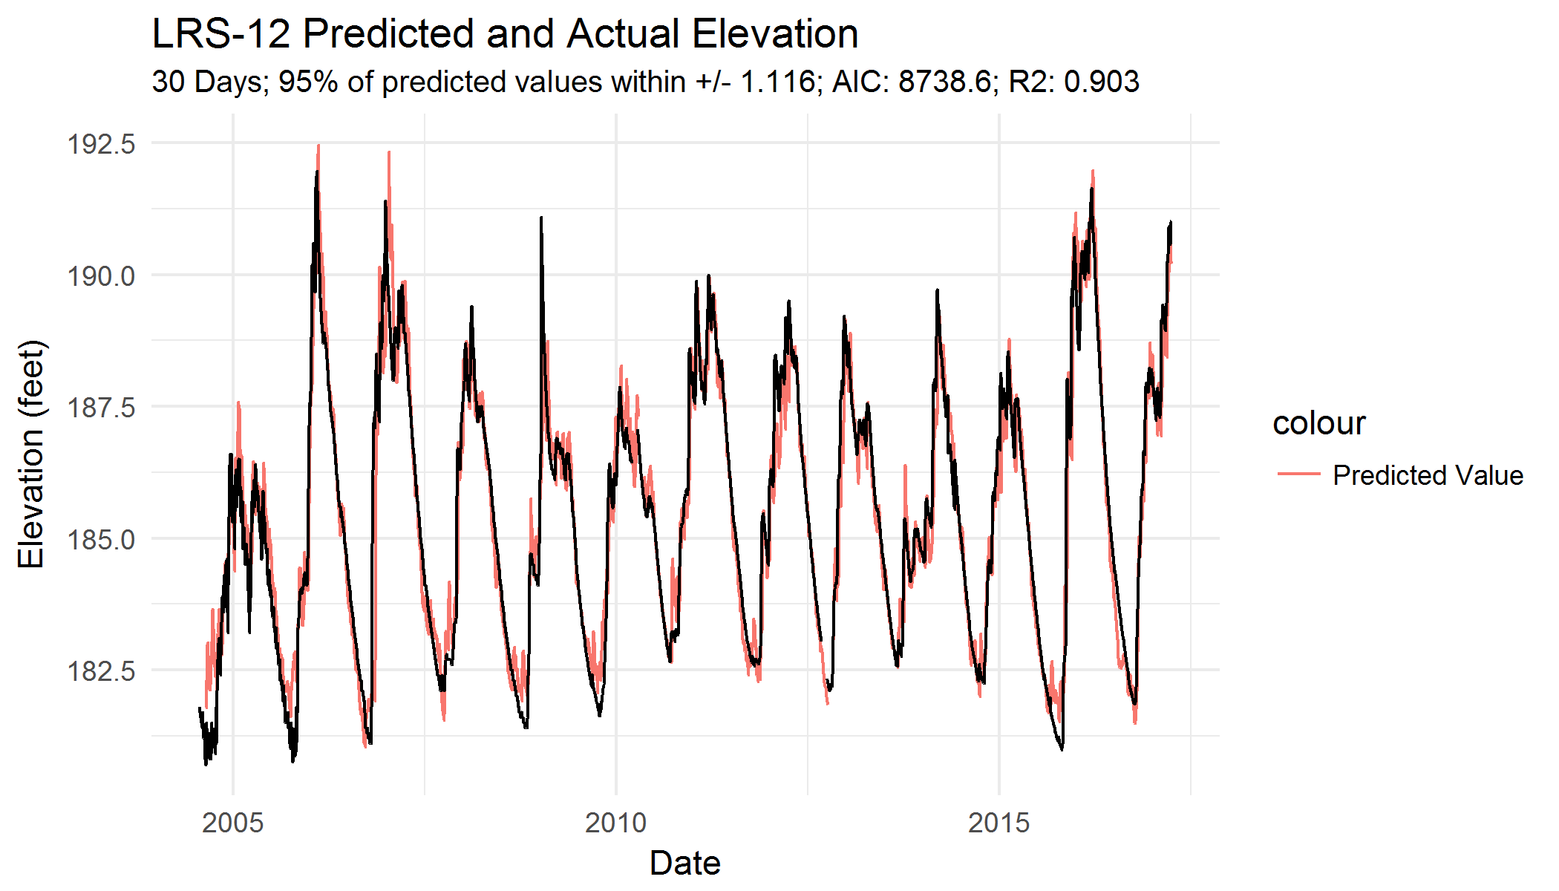

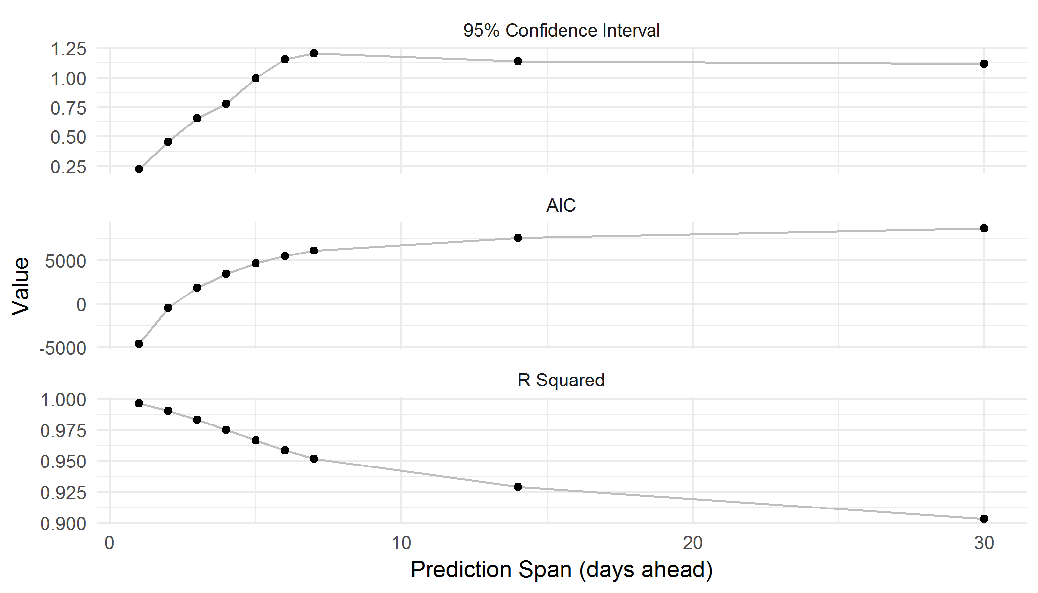

## MW-3

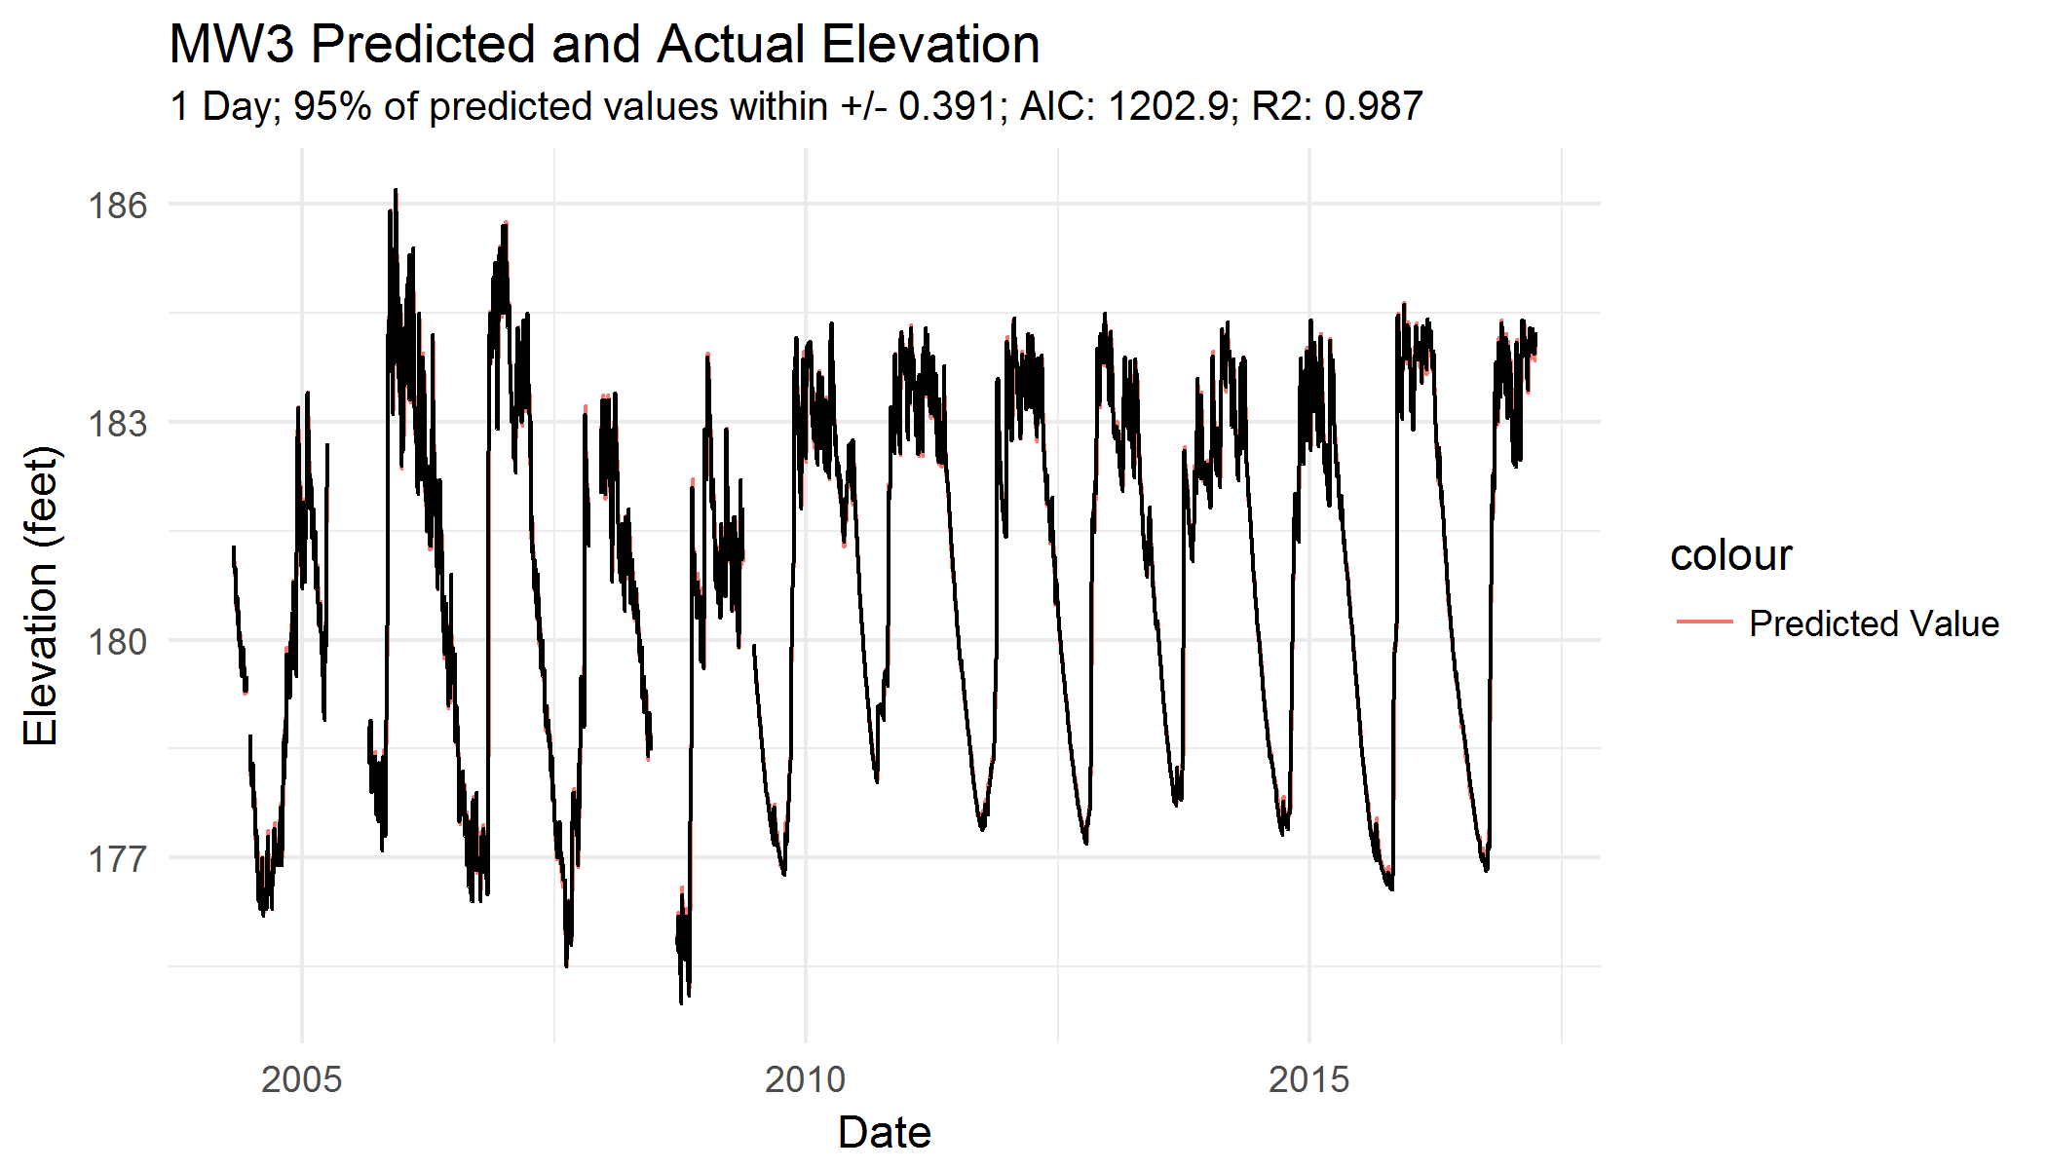

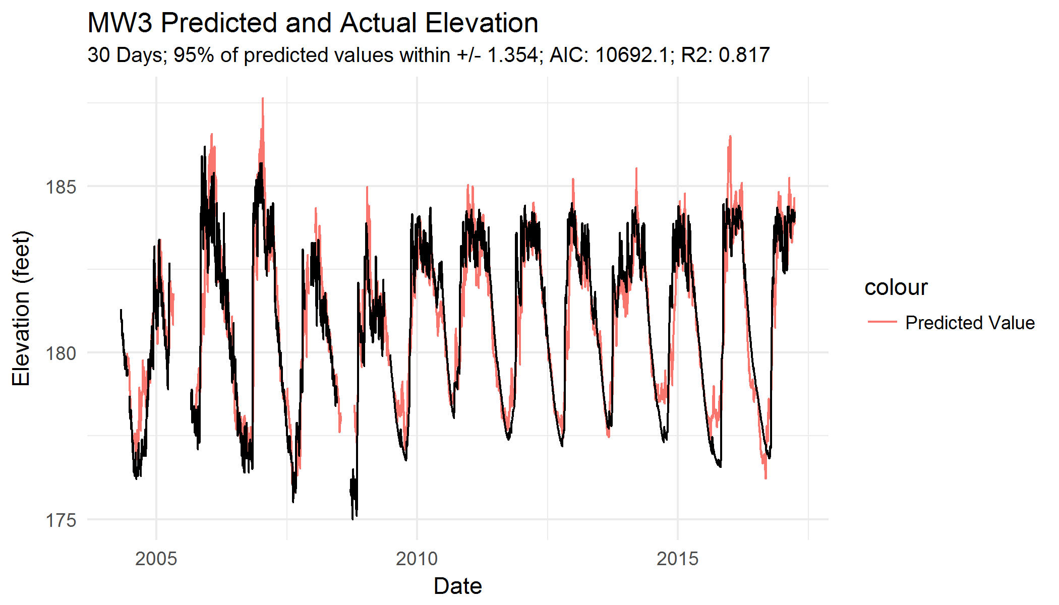

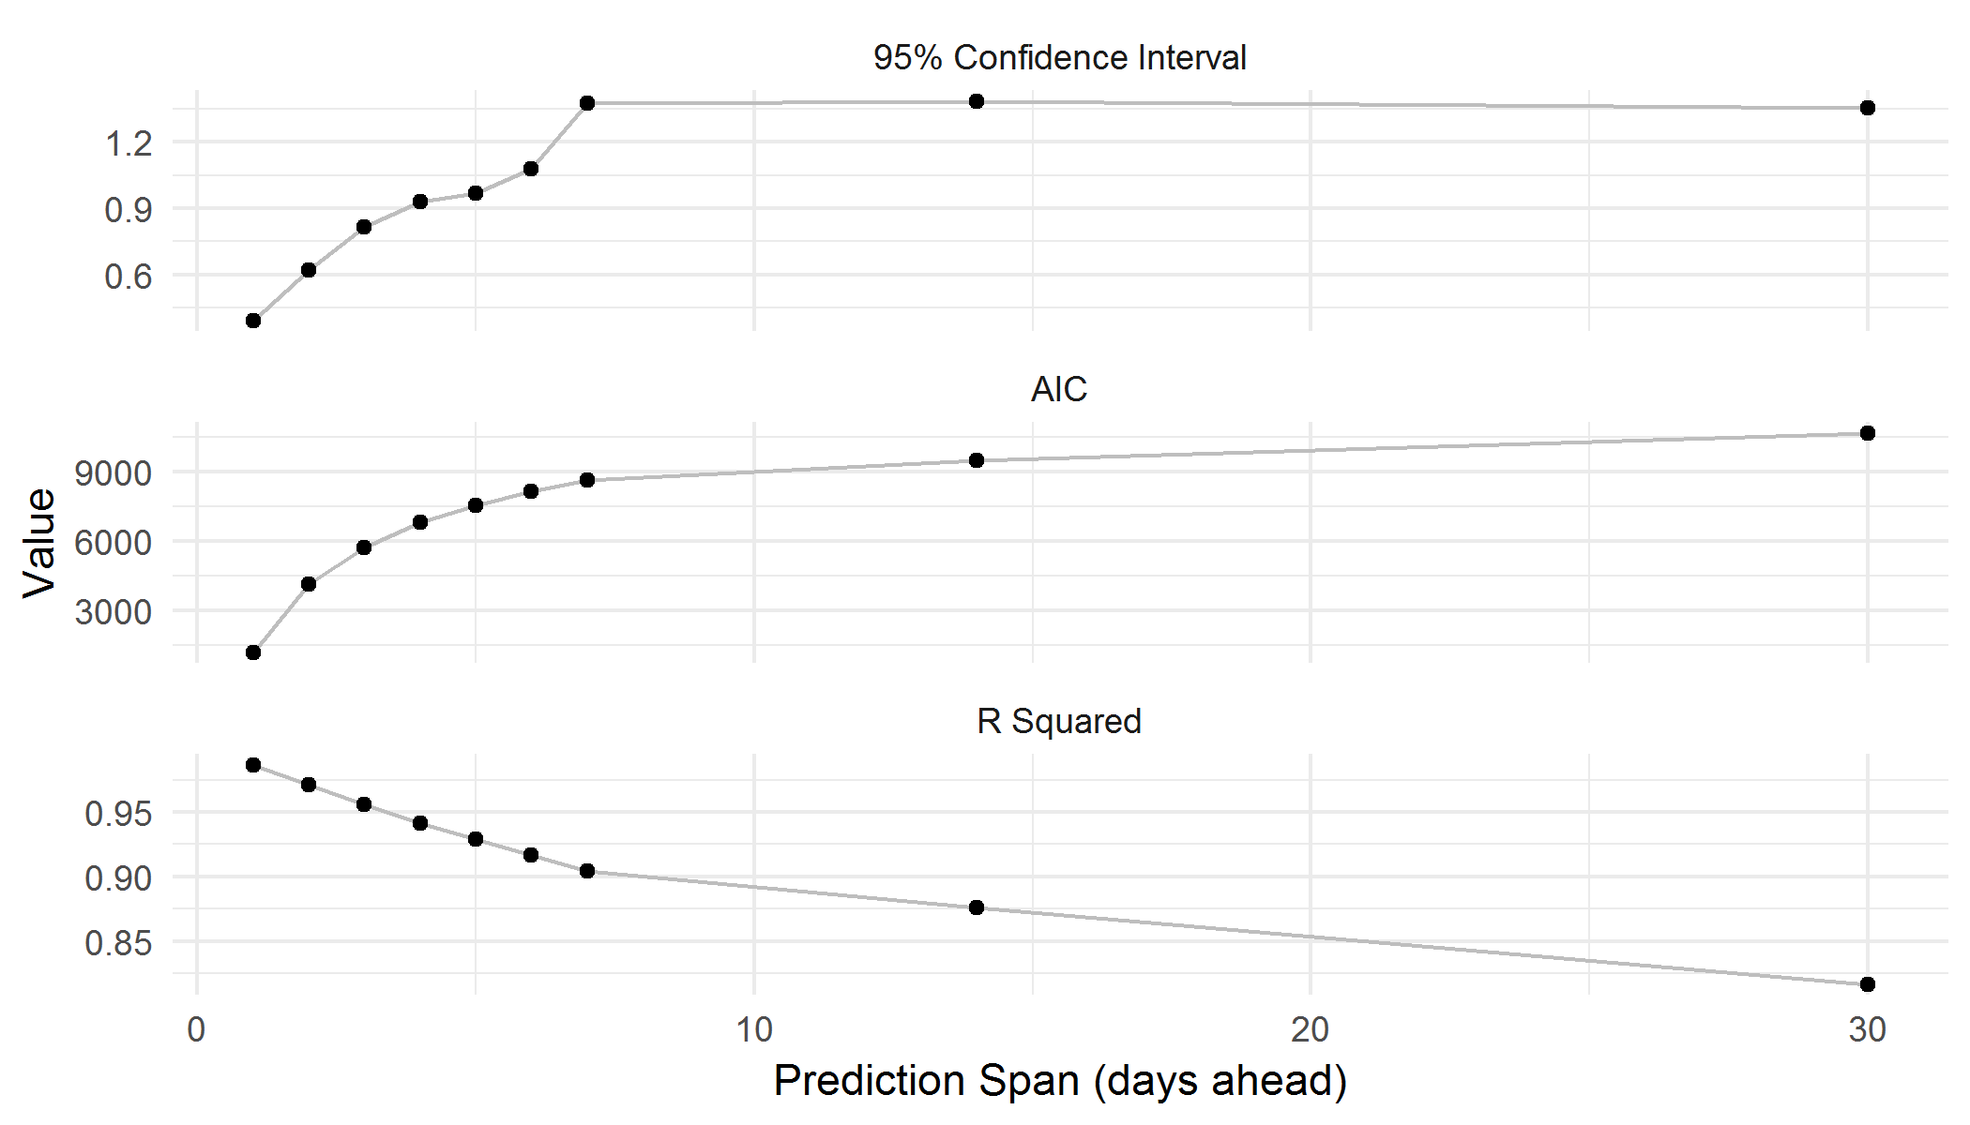

## MW-5

